Unicommerce Test (JavaScript)
============================================
You are requested to read carefully and follow all the instructions!
Problem Statement: You are requested to create a slideshow app.
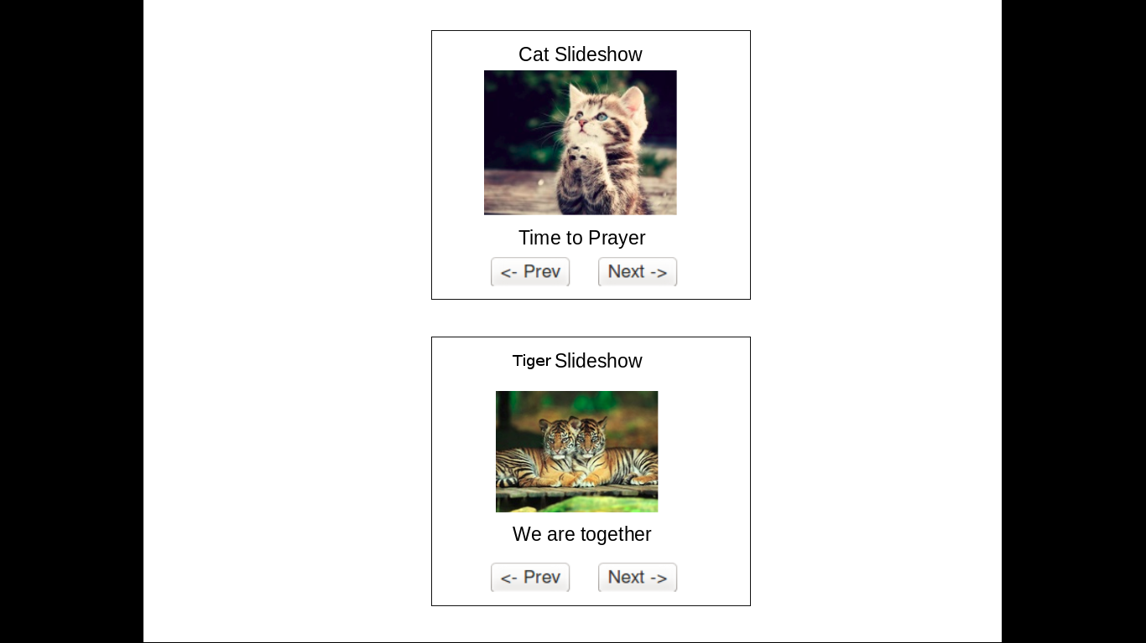
and this is how it should look finally.

This will be a very minimal Slideshow app (utility). All you need to do is show one image at a time and below the image you need to put Caption of image and two buttons (prev and next) for navigation!
- When we click prev button, it will go to the previous image.
- If we click next button then the next image will appear.
- Image and caption both will change on clicking the button.
So, all you need to do is create a top level function like this:-
function initSlideshow(<dom Node>, <configuration>);
Example

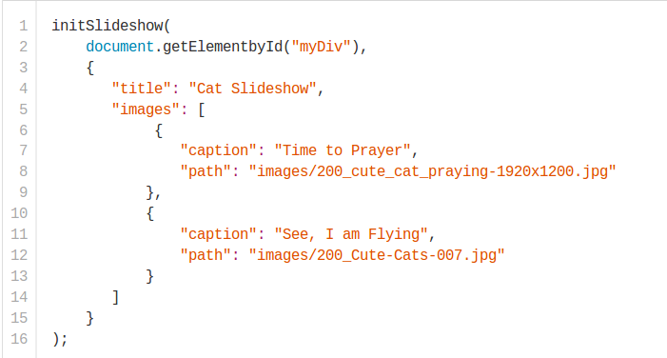

initSlideshow function takes two arguments,
First is the dom node where you need to initialize whole slideshow. That means, before calling the initSlideshow function, the div was empty. Something like this
<div id="myDiv"></div>
After calling the initSlideshow function, the Slideshow will be loaded inside this empty element (loading images, button, assigning click handler etc).
The second argument will be the configuration object.
We are attaching the configuration object in json file. You must not copy paste this json file into your JavaScript file, instead you need use the file as it is. You need to create a XHR call to get the file and pass the object as second argument.

You need two Empty Divs for creating two slideshow.
<div id="myDiv"></div>
<div id="myDiv1"></div>
and call initSlideshow twice (first time with configCat.json and configTiger.json)

We have added two json files and some images for your.
Here are some important points.
1. You MUST NOT use any JavaScript framework or library.
2. You MUST to write in Object Oriented code (function constructor and prototypal inheritance for methods) or may be better.
3. You MUST load both slideshow.
4. initSlideshow can be wrapper function and you can write your code outside of this function in your style and then call main method from initSlideshow function.
5. You can apply basis CSS but need not to decorate much. Only JavaScript code will be evaluated.
6. We will only see the code quality and approach.

